Review

GREEN CORROSION INHIBITOR

(AGAVE AMERICANA, PONGAMIA PINNATA, EICHHORNIA CRASSIPES)

A Current Perspective

Thilothamma M Ms. Vennila (Guide)
Department of Agricultural Eng Department of Civil Eng Kalaignarkarunanidhi Institute of KIT-Kalaignarkarunanidhi Institute of Technology, Coimbatore Technology, Coimbatore thilothammamani@gmail.com Vennila212@gmail.com
Athistalakshmi P Rohith S
Department of Agricultural Eng Department of Agricultural Eng Kalaignarkarunanidhi Institute of Kalaignarkarunanidhi Institute of Technology, Coimbatore Technology, Coimbatore
athistalakshmi200625@gmail.com rs4534298@gmail.com

ABSTRACT:
Corrosion is still a major industrial concern, causing severe corrosion of metallic structures and resulting in significant economic and environmental losses worldwide. Effective conventional inorganic inhibitors like chromates, phosphates and nitrites but possess serious disadvantages because they poison, lack biodegradation and persist in the surroundings. As it was found that alternatives that can be used as environmentally-friendly substitutes, current studies are focused on the development of green corrosion inhibitors produced by using plant substances. These natural compounds, rich in alkaloids, flavonoids, tannins, saponins, and other phytochemicals, have considerable adsorption capabilities on metal surfaces through heteroatoms (O, N, S) and π-electron systems. They produce protective layers that limit corrosion reactions. The extracts were made using aqueous and ethanolic extraction, followed by concentration under decreased pressure to produce crude inhibitor solutions. (SEM), (EDS), (FTIR) were used to assess surface morphologies and inhibition performance throughout a concentration range of 50-1000 ppm. demonstrated that inhibitory efficacy improved with concentration, reaching levels greater than 90% at optimal dosages. The observed increase in charge transfer resistance and shift in corrosion potential verified mixed-type inhibitory behavior characterized by adsorption and film formation.
The FTIR analysis conducted on the metal surface showed the existence of -NH and this shown that the phytoconstituents were physically and chemically adsorbed to the metal surface. It is found that plant-based extracts offer a sustainable, biodegradable, affordable way of corrosion protection that can be compared to many synthetic corrosion inhibitors, or even exceed them. Furthermore, the proposed inhibitor's ecologically friendly nature makes it appropriate for large-scale industrial applications such as pipelines, chemical processing equipment, and maritime constructions. This research thus contributes to the improvement of green chemistry and surface engineering, encouraging a transition toward safer and more sustainable corrosion control approaches.

Keywords: corrosion inhibitors, Adsorption, Metal surface protection, Organic inhibitors, green corrosion Inhibitors.

INDRODUCTION:

The process of corrosion is strictly a product of electrochemical processes in which metal slowly and progressively decays due to the exposure of the product to the elements of the environment (i.e. moisture, air, etc.). This has a wide-ranging economic impact that manifested not only in huge costs of damages to the structural integrity of metallic parts, but it also translates into large-scale economic damages, jeopardized safety, and inefficiency in the operations of various industries, including transportation, construction, energy, and chemical processing. Corrosion expenses according to the estimates of the world are greater than 3,4 percent of the GDP of the industrialized countries every year, and there is an urgent necessity to develop effective and durable methods of dealing with corrosion.
Corrosion inhibitors are one of the most effective and economical corrosion-reduction measures espoused among the numerous other measures in place like coating, cathodic protection and even altering the material. Corrosion inhibitors are a chemical isotope that when added in small quantities to the corrosive media significantly retard the occurrence and rate of dissolution of metal and hydrogen evolution. These compounds have a significant working mechanism of adsorbing slender, barrier separates the species. Depending on the structure of the inhibitor, and the type of metal and environment, the inhibition process may involve physical adsorption (physisorption), chemical adsorption (chemisorption), or complex formation.
In this respect, much attention has been paid to green corrosion inhibitors produced primarily on the basis of plant extracts, natural polymers and bio-based chemicals. Plants contain a number of organic chemicals among them alkaloids, tannin, flavonoids, terpenoids, saponins and amino acids. These molecules possess hetero-atoms (O, N, S, P) and π-electron systems which are able to contribute electrons to empty metal orbitals. As these molecules they thicken, adsorbing protective coating which stops these two natural inhibitors is not only practical, but also biorenewable, nontoxic as well as biodegradable which are advantageous in long-term corrosion management.
TYPES OF PLANTS:
1. AGAVE AMERICANA (Main usage)
2. PONGAMIA PINNATA
3. EICHHORNIA CRASSIPES

AGAVE AMERICANA:

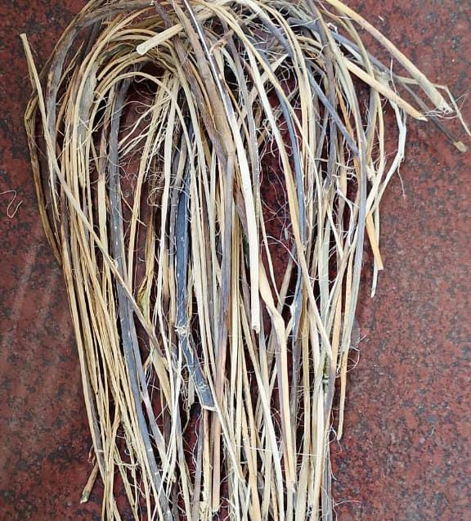
Originating in Mexico, also known as agave americana varity of algae Despite the long been used create produce beverages significant amount routinely discarded as waste. succulent that is now widely grown in many arid and semi-arid regions. It can be differentiated by its incredibly large, thick, fat leaves with sharp spines covering the edges, and its high-growing stalk of blooming that will only bloom In harsh environments that can follow and could stick against the steel surfaces creating some kind of a barrier that prevents corrosion. Because of its rich bioactive profile, low economic value, and abundance.Phytochemical research indicates that Agave americana contains tannins, alkaloids, flavonoids, phenolic chemicals, and saponins that have antibacterial, antioxidant, and metal-binding properties.
PONGAMIA PINNATA:
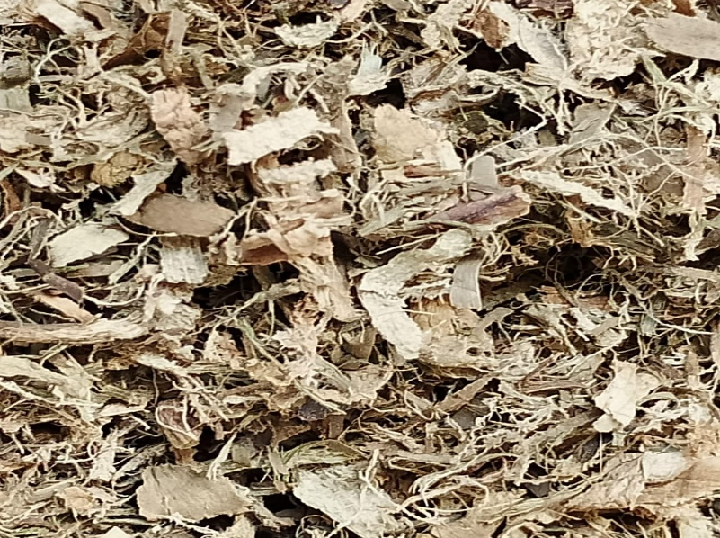
Along with their commercial uses, including routinely discarded Phytochemical analyses have revealed that Pongamia pinnata, a medium-sized leguminous tree native to Southeast Asia and the Indian subcontinent, is also known as Indian beech or Karanja. Its abundance, affordability, and bioactive richness make it a good choice for "waste-to-wealth" corrosion control applications that are environmentally friendly. Its inedible seed oil is widely used for biodiesel production, traditional medicine, and agroforestry. In acidic and saline environments, these bioactive substances form a barrier that prevents corrosion by sticking firmly to steel surfaces. Pinnata is an excellent environmentally friendly alternative to synthetic inhibitors because it has shown greater efficacy in corrosion inhibition trials than many other plant extracts. These substances have antioxidant, metal-chelating, and antibacterial properties.
EICHHORNIA CRASSIPES:
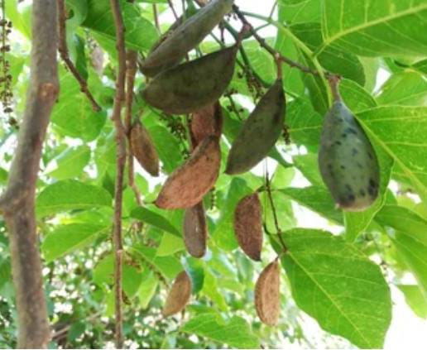
Eichhornia crassipes is an invasive aquatic weed species commonly found in water as the so-called water hyacinth recorded first but since it was discovered globally. Water hyacinth or Eichhornia crassipes is an invasive aquatic weed, which was first discovered but since it also has a global presence. One of the significant features of this plant is its purple flowers, glossy green leaves, and swollen petioles that help it to lift. As irritating as it can be, water hyacinth has positive phytochemicals like flavonoids, tannins, alkaloids, and phenolic compounds that are able to adsorb onto metal surfaces and create a protective coating. These chemicals ensure resistance against corrosion by suppressing the presence of the hostile ions present in acidic and saline conditions. Its application assists in controlling an alien species and facilitates the waste-to-wealth principle in a factory environment by transforming Eichhornia crassipes into a biodegradable, sustainable and cost effective corrosion inhibitor.
Corrosion inhibitors are classified into two types: those that act as cobalt-complex agents and those that act as nickel-complex agents.<|human|>CORrosion Inhibitors divided into two categories: Corrosion inhibitors fall into two categories: those inhibitors that are cobalt-complex agents, and those that are nickel-complex agents.
There are various ways in which corrosion inhibitors are classified by chemical composition, mode of action and the stage of the application phase. The classification helps in their clear comprehension of clear behavior, interaction, and adaptability to different environment or industry conditions. There are broadly classified corrosion inhibitors into the following categories:
ADSORPTION AND MECHANISM:
The ability of corrosion preventatives to and form a barrier is essentially their ability to prevent active corrosion sites, inhibit ion transportation, and have minimum electrochemical reactions with the metal surface [2]. The gauges of this adsorption layer are the nature, strength and stability which defines the overall efficacy of inhibition. An interaction between an inhibitor and the metal surface leads to the formation of a thin coating that acts as a shield between the metal and the corrosive elements of hydrogen ions, oxygen, chloride or sulfate ions. [1]Once an inhibitor enters into a corrosive medium, the molecules of the inhibitor reacts with the metal surface either physically or through chemical interaction. The extent of surface coverage (θ) caused by the molecules of the inhibitor is usually analyzed through adsorption isotherm including the Langmuir, Temkin, Freundlich or Frumkin isotherms, which depend on the level of protection.
Green (natural) corrosion inhibitors — extraction and preparation:
1.Batches of 10–100 g of dried plant material (leaves, bark, and seeds).
2.Analytical 95% ethanol and deionized or distilled water.[3]
3.n-Hexane, ethyl acetate, and dichloromethane (DCM) are optional fractionation solvents.
4.Acetone for degreasing; mild steel coupons (SAE 1020/1006 or standard composition).
5.For evaluating acidic corrosion, use 1.0 M HCl or any corrosive liquid as needed.
6.Platinum counter electrode, Ag/AgCl reference electrode.
7.Nitrogen gas (optional; used for inserting during concentration).
Tools:
1.To pulverize plant material, use a grinder or mill.
2.Oven for ironing (40–60 °C).
(Optional) Soxhlet extractor.[5]
3.Vacuum rotary evaporator.
4.Filtration configuration (Whatman filter/Buchner funnel).
5.Balance of analysis (±0.1 mg).
conductivity and pH meters.
6.Potentiostat, an electrochemical workstation featuring polarization and EIS capabilities.
7.FTIR, SEM, and (if accessible) XPS.
8.For better extraction, an ultrasonic bath is optional.
Extraction methods (three approved choices):
1) Aqueous boiling
Use it when you want an extract that is entirely aqueous and leaves no residue from organic solvents.
Plant material should be dried to a consistent weight at 40–50 °C. Grind to a fine (~0.5 mm) powder [6].
Put 10.0 g of dried powder in a 500 mL beaker after weighing it. Pour in 100 milliliters of 10% w/v distilled water.
Bring to a gentle boil (about 95 °C) and keep for 30 minutes, stirring occasionally. (Alternatively, depending on the matrix, simmer for 20 to 60 minutes.)
After cooling to room temperature, collect the filtrate by filtering it through Whatman No. 1.
To get crude aqueous extract, concentrate the filtrate at -40°C under decreased pressure (rotary evaporator); note the mass (yield % = mass extract / dry plant mass × 100).[7]
As stated in Section D, reconstitute to a known concentration.
Notes: Beneficial for polar phytochemicals (sugars, tannins). Quick and inexpensive.
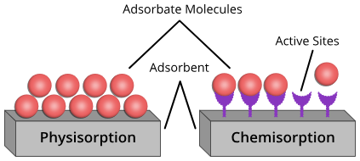
2) Broad-spectrum extraction, or ethanol maceration:
Ethanol is frequently used for green inhibitors and may remove both polar and mid-polar molecules.
As above, dry and grind the plant. Weigh out 10.0 g of powder.
Put the powder in a 250 mL amber bottle and then pour in 100 mL of 95% w/v ethanol.[10] Shake and seal.
Macerate for 48 hours at room temperature, shielded from the light, shaking occasionally; alternatively, use an orbital shaker set to 150 rpm.[9] (Optional: 30 minutes of ultrasonication to speed up.)
Use Whatman to filter No. 1: Gather the filtrate. To increase yield, repeat extraction on residue once more and blend filtrates.
The crude ethanolic extract is obtained by removing the solvent at -40°C under decreased pressure (rotavap). Note the yield.
To get rid of any remaining ethanol, vacuum-dry the residue. Reconstitute at the appropriate stock concentration in a solvent (ethanol/water).
The crude ethanolic extract is obtained by removing the solvent at -40°C under decreased pressure (rotavap). Note the yield.
To get rid of any remaining ethanol, vacuum-dry the residue. Reconstitute at the appropriate stock concentration in a solvent (ethanol/water).
Notes: Ethanol is safer and has a greener profile than methanol.[11] produces more extensive active substances (phenolics, alkaloids, and flavonoids).

3) Soxhlet extraction, which is effective for through extraction:
Use if you have the necessary tools and require a complete extraction.
Put 20.0 g of dried powder in a thimble made of cellulose. Use about 300 milliliters of solvent (either ethanol or ethanol: water 80:20).
For 6 to 8 hours, run Soxhlet (6 to 10 cycles per hour on average).
To create a concentrated crude extract, remove the solvent using rotavap at -40 °C. Calculate the yield and vacuum-dry.
Notes: Ideal for preliminary work at the lab scale when quantitative extraction is needed.
Fractionation and cleaning (not required, but advised for mechanism investigations)
Use as little distilled water (or methanol) as possible to dissolve the crude extract. Next, execute liquid–liquid partitioning: hexane (which eliminates nonpolar lipids) → DCM → ethyl acetate → aqueous residue. Second, make distinct fractional concentrations.[13] To determine the active polarity class, look for inhibitory activity in each percentage. Keep portions at 4 °C in amber vials.
and dosing stocks (useful concentrations for corrosion tests) For the crude extract stock (which is advised), make a stock solution of 1 g/L (1000 ppm). [15] As an illustration: 1000 ppm stock is made by 100 mg of crude extract in 100 mL of solvent (ethanol: water 1:9). Dissolve in a small amount of ethanol (≤10% v/v final) initially, then dilute if solubility is low. Screening working concentrations are 50, 100, 200, 500, and 1000 ppm (mix the corrosive medium with the proper aliquots of stock). (Optional) controlled release or microencapsulation:
1. To make alginate beads, for instance, dissolve 5% w/w extract in water, combine it with 2% w/v sodium alginate, and then add it dropwise to 0.1 M CaCl₂. Wash and dry.[16] Comprehensive corrosion test procedures Using coupons made of mild steel to prepare the sample Cut coupons to 20 mm × 20 mm × 2 mm, for instance (or 25 × 15 × 2 mm); make a note of the precise specifications. An example would be an exposed area of 4.0 cm².
2. Use SiC emery sheets to polish in increments of 400 → 600 → 800 → 1200 grit to get a reproducible surface.
3. Use an analytical balance to weigh (record the starting mass m₀ to ±0.1 mg), rinse with ethanol, dry in warm air, and use an ultrasonic for five minutes to degrease in acetone.
4. If testing a specific location, cover the entire area with lacquer or epoxy, excluding the designated spot. Gravimetric test for weight loss Make sure the corrosive medium is ready (e.g., 250 mL per beaker of 1.0 M HCl). Place the inhibited solutions with the chosen extract concentrations next to the blank (no inhibitor). In a thermostatic bath, set the temperature to 30 ± 1 °C. Submerge pre-weighed coupons completely (make sure they are oriented the same way). Run each condition three times.
Remove coupons after exposure (24, 48, or 72 hours; select durations), rinse with distilled water, neutralize corrosion with sodium bicarbonate, if necessary, wash with ethanol, dry, and weigh (m₁). Determine the inhibition efficacy and corrosion rate: Corrosion rate (CR) = (m₀ − m₁) / (A × t) (mg cm⁻² h⁻¹) The effectiveness of inhibition (IE_wt %) is equal to [(CR_blank − CR_inh) / CR_blank] × 100 A stands for exposed area (cm2), and t for time (h).
Various Electrochemical assays (best used to examine mechanism) Standard three-electrode cell configuration: platinum mesh (use as counter-electrode), Ag /AgCl (saturated KCl) (use as reference-electrode), and a prepared coupon (exposed geometric area of 1 cm ) (use as working electrode)..

METHODOLOGY:
1. Submerge with an inhibitor and without an inhibitor with the given concentrations (1.0 M HCl) in the test solution. Wait it 30 minutes at open circuit potential (OCP).
2. EIS: AT a 10 mv ac perturbation around OCP, over a beta frequency band of 100 possible frequency to 10 mHz. Get the Bode and Nyquist graphs. In order to get R p (polarization resistance), fit an equivalent circuit.
.
Surface characterization (to verify film formation and adsorption)
1. SEM/EDS: execute elemental mapping to see organic film elements (C, O, N) after rinsing the coupon in distilled water, drying, mounting, and imaging surface morphology following corrosion tests.
2. To identify such N–H, FTIR (attenuated total reflectance, or ATR) is used to gather spectra of pure extract and of film scraped off the coupon.
3. In case it is accessible, one can use the XPS to analyze the chemical states on the metal surface, including the alterations that indicate that the metal and N/O atoms are in coordination..
4. Check if the inhibitor film increases hydrophobicity by measuring the contact angle.
QC, repeatability, and stability Thermal stability: assess the effectiveness of inhibition by heating small aliquots of extract to 60°C and 80°C for 24 hours. This measures thermal robustness. Shelf life: keep inventory at 4 °C and check for activity drop every month for three months. Maintain batch uniformity by keeping track of each batch's yields and phytochemical fingerprint (FTIR/HPLC). Accept a yield/active profile fluctuation of less than 10%.
Environmental and safety factors Wear PPE (lab coat, goggles, and gloves) at all times. Use a fume hood while working with organic solvents. As directed by the institution's hazardous waste procedures, dispose of acid solutions and solvent waste. If allowed, neutralize acidic solutions before discarding them. For a greener profile, use water and ethanol extractions instead of hazardous solvents. Handle plant material appropriately (masks, reduced dust) if it is hazardous or allergic.
The part on ready-to-paste methods for your paper You can copy and paste the following section into the Materials and Methods section of your paper. Change the solution selections and plant name as necessary.
During the first six hours, the inhibition's effectiveness rose with temperature; it peaked at 85% efficiency at 1000 ppm and stayed steady-state for the full twelve hours of immersion. The adsorption on the surface was heterogeneous, endothermic, and spontaneous. Because the inhibitor adsorbs, is followed by the inhibitory activity.
leaves extracted using showed concentration of this inhibitor degrees Celsius, demonstrating that its efficacy increased with concentration. However, the inhibitory performance showed 86% protection. It has been demonstrated that the Paederia foetida leaf extract inhibits corrosion in percent—following day of exposure.

CONCLUSION:
One of such practical and economical methods of countering the corrosion process in metallic products in unfavorable contexts is corrosion inhibition. The corrosion inhibition adsorption and mechanism provide a basic influence in the study of the inhibition efficiency since the interface that exists between the metal surface and the inhibitor molecules is the target of study. This process regulates the formation, the strength, and durability of the protective coating which protects the metal against the corrosive components such as oxygen, ions of chloride and moisture.
The phenomena involved in the inhibitation revolve around the adsorption process which could be physical or chemical. Physically adsorbed inhibitors involve weak electrostatic interactions to provide a reversible protection whereas chemically adsorbed inhibitors involve strong coordinate or covalent bond to the metal atoms, creating a more permanent and lasting barrier. The adsorption activity is in agreement with the established theories including Langmuir, Freundlich and Temkin isotherms, theories that explain the way the inhibitor molecules are deposited or positioned on the metallic surface. The estimated thermodynamic values, most especially that of free energy of adsorption ( ΔG°ads ) are signals of adsorption type and stability of the film. A negative value of values less than -40 kJ/mol is an indication of chemisorption, and the opposite is a sign of physisorption.
The current study of molecular design, computational modeling, and the green chemistry perspective has colossal potential in the production of the next generation of inhibitors, which are effective, economical and environmental friendly. The knowledge of the adsorption mechanism can therefore offer critical information on corrosion science as well as is the gateway to novel types of material protection particularly in the industrial, marine, as well as infrastructure environments.

REFERENCE:
[1] Salleh, Siti Zuliana et al. "Plant extracts as a green corrosion inhibitor system on ferrous metal alloys: A review. J Cleaner Production 304 (2021): 127030.
Peter, Anjali, I. B. Obot and Sanjay K. Sharma. Gupta, Kumar, and Secore 2014. "Use of natural gums as green corrosion inhibitors: an overview." International Journal of Industrialchemistry 6.3 (2015): 153164.
[3] Hossain, Nayem, Mohammad Asaduzzaman Chowdhury and Mohamed Kchaou. "Surveillance of green corrosion inhibitors to achieve sustainable and environmental friendly industrial development. Jadesition science and technology, 35.7 (2021): 673-690.
[4] Marzoratti, Stefania, Luisella Verotta, Stefano P. Trasatti. Green corrosion inhibitor extracts: biomass wastes and natural resources. Molecules 24.1 (2018): 48.
Xhanari, Klodian et al. "A review of green corrosion inhibitors of aluminium and its alloys looking forward. RSC advances 7.44 (2017): 27299-27330.
[6] Alao, Alice Osheiza, et al. "Alo, The use of green inhibitors as a sustainable technique of corrosion control over steel in the petrochemical industries: A review. Frontiers in Energy Research 10 (2023): 1063315.
Parangusan, Hemalatha, et al. "Plant extract as green corrosion inhibitors in carbon steel substrate in varying environments: A system review article. International electrovette Society of chemistry 20.4 (2025): 100919.
Sharma, Sanjay K. and Alka Sharma. Green corrosion inhibitors, status in the developing nations. Opportunities and challenges of green corrosion chemistry and engineering (2011): 157-180.
de Souza Morais, Williams Raphael, et al. "Green corrosion inhibitors using plant extracts in metals and alloys under corrosive condition: technological and scientific perspective of technology and science. Applied Sciences 13.13 (2023): 7482.
Patni, Neha, Shruti Agarwal and Pallav Shah. Information Technology Newsmaker: "Greener approach towards corrosion inhibition." Chinese Journal of Engineering 2013.1 (2013): 784186.
Moretti, Giuseppe, Francesca Guidi, and G. Grion. Tryptamine as a green iron corrosion inhibitor in deaerated 0.5 M sulphuric acid. Corrosion science 46.2 (2004): 387-403.
Sharma, Sanjay K., Anjali Peter and Ime Bassey Obot. Potential of Azadirachta indica as a green corrosion inhibitor of mild steel- aluminum and tin- a review. J Analytical Science and Technology 6.1 (2015): 26.
Murthy, Z. V. P., and K. Vijayaragavan. Mild steel corrosion inhibition using acid extract of leaves of Hibiscus sabdariffa as a green corrosion inhibitor and sorption behavior. Green Chemistry Letters and Reviews 7.3 (2014): 209-219.
[14] Verma, C., E. E. Ebenso and M. A. Quraishi. Alkaloids as environmentally non-toxic and green corrosion inhibitors: A summary. international journal of corrosion and scale inhibition 8.3 (2019): 512-528.
Verma, C., E. E. Ebenso and M. A. Quraishi. "Green and environmental benign corrosion inhibitors: an overview of alkaloids. Corrosion and Scale Inhibition International Journal 8.3 (2019): 512-528.
[16] Obot, I. B., S. A. Umoren, and N. K. Ankah. Pyrazines derivatives as oil field corrosion inhibitors on steel as a green method. Molecular Liquids, 277 (2019): 749-761.
Ating, E. I., et al. "Leaves extract of Ananas sativum as green corrosion inhibitor on aluminium in solutions of hydrochloric acid. Green Chemistry Letters and Reviews 3.2, (2010): 61-68.
Rizi, Aicha, et al., "Sustainable and green corrosion inhibition of mild steel: electrochemical and computational studies insights." ACS omega 8.49 (2023): 47224-47238.
Asipita, Salawu Abdulrahman, et al. "Green Bambusa Arundinacea foliage decoction as sustainable corrosion even in steel reinforced concrete. J Cleaner Production 67 (2014): 139-146.
Umoren, Saviour A., et al. "Investigation into the natural polymers as a green corrosion inhibitor of AZ31 magnesium.
alloy in saline environment." Carbohydrate polymers 230 (2020): 115466

